PHYSICAL EDUCATION STUDIES

ATAR Unit 1 and Unit 2

Semester 2 Examination, 2019

Question/Answer Booklet

Students, please place your name in this box

Student Number: | Figures
 | Words

Time allowed for this paper

Reading time before commencing work: ten minutes
Working time for paper: two and a half hours

Materials required/recommended for this paper
Number of additional
answer booklets used
(if applicable)
To be provided by the supervisor

This Question/Answer Booklet
Multiple-Choice Answer Sheet

To be provided by the candidate
Standard items: pens (blue, black preferred), pencils (including coloured), sharpener, correction fluid/tape, eraser, ruler, highlighters
Special items: non-programmable calculators approved for use in the WACE examinations

Important note to candidates

No other items may be taken into the examination room. It is your responsibility to ensure that
you do not have any unauthorised notes or other items of a non-personal nature in the
examination room. If you have any unauthorised material with you, hand it to the supervisor
before reading any further.

Structure of this paper

Section | Number of questions available | Number of questions to be attempted | Suggested working time  (minutes) | Marks available
Section One: Multiple-Choice | 20 | 20 | 30 | /20
Section Two: Short Response | 12 | 12 | 75 | /60
Section Three: Extended Response | 4 | 2 | 45 | /30
 |  |  | Total Marks | /110
 |  |  |  | %

Instructions to candidates

1. The rules for the conduct of this exam have been outlined. Sitting this examination implies that you agree to abide by these rules.

2. Answer all questions according to the following instructions.

Section One: Answer all questions on the separate Multiple-choice Answer Sheet provided. Use only a blue or black pen to mark your answer with an X. If you make a mistake, place a cross through that square, do not erase or use correction fluid, and cross your new answer. Marks will not be deducted for incorrect answers. No mark will be given if more than one answer is completed for any reason.

Section Two and Three: Write answers to in this Question/Answer Booklet.

3. You must be careful to confine your responses to the specific questions asked and to follow any instructions that are specific to a particular question.

4. Spare pages are included at the end of this booklet. They can be used for planning your responses and/or as additional space if required to continue an answer.
- Planning: If you use the spare pages for planning, indicate this clearly at the top of the page.
- Continuing an answer: if you need to use the space to continue an answer, indicate in the original answer space where the answer is continued, i.e. give the page number. Fill in the number of the question(s) that you are continuing to answer at the top of the page.

SECTION ONE – MULTIPLE CHOICE (20 marks)

Record an answer for questions 1 – 20 by marking your choice on the separate Multiple-Choice Answer Sheet using a blue or black pen or a B or 2B pencil. Each question is worth one mark.

If you make an error, follow the instructions given to you on the Multiple-Choice Answer Sheet.

Suggested working time for this section is 30 minutes.

A runner’s progress was tracked as shown below
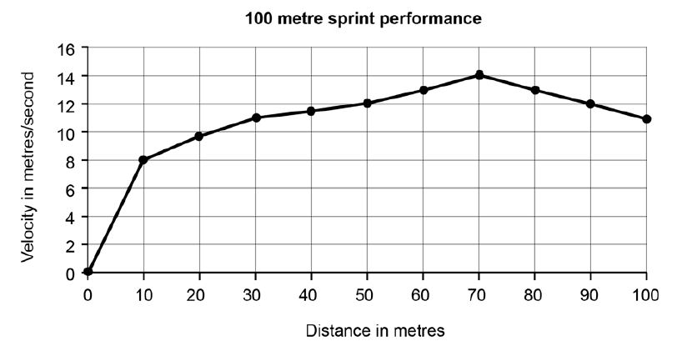

- Which one of the following represents the most accurate interpretation of the data from the graph?
- he runs up a hill then heads down a small slope at the end
- he shows uniform acceleration throughout most the run
- his displacement is greatest at the 70 metre mark
- he decelerates after the 70 metre mark

- The optimum angle of release for objects traveling maximum distance is:
- determined by the centre of gravity of the athlete throwing it
- generally lower than the 45 degrees of release for a situation where the release point is higher than the landing
- more than 45 degrees
- increased for sports where velocity of release is the most critical factor

- In soccer, the goalie must respond to ‘shots on goal’ as quickly as possible. Although not ideal, a goalie with lower levels of speed or agility may still be successful if they possess an exceptional level of which of the following components of fitness?
- cardiorespiratory endurance
- coordination
- flexibility
- reaction time

- In basketball, a player who is fouled while taking a shot is often rewarded a ‘free throw’, whereby the player is allowed to attempt a shot without any defenders involved. The basketball free throw would be classified as which of the following motor skills?
- open, discrete and fine
- closed, discrete and gross
- closed, serial and gross
- open, serial and fine

- Muscle fibres can be classified into two distinct types. Type II – white muscle fibres are best characterised by:
- slow speed of contraction, high endurance qualities, large in size
- low in endurance qualities, anaerobic, large in size
- prevalent in the quadriceps muscle of marathon specialists and postural muscles
- having an extensive blood supply

- When the hamstring muscle is contracts concentrically, what action is occurring about the knee joint?
- eccentric extension
- flexion
- isoflexion
- isokinetic stabilisation

- Muscles have four main characteristics. One of the characteristics is ‘extensibility’ and it is characterised by
- the muscles elasticity
- the body’s adiposity or body fat
- a muscle’s ability to develop tension whilst shortening
- the muscles ability to stretch beyond its normal resting length

- When commencing exercise, it takes time for oxygen consumption to increase, resulting in:
- an oxygen deficit
- a tidal volume
- an arteriovenous difference
- anaerobic metabolism of fat

- The aerobic system:
- is capable of producing the largest amount of ATP
- uses glucose to breakdown ADP with a by-product of ATP
- both a) and b)
- is least likely to be used at rest

- Blood is redistributed at the start of exercise with the assistance of:
- a decrease in stroke volume
- vasoconstriction and vasodilation
- maximal oxygen consumption
- lactate threshold

- What type of attention focus does a tennis player need when preparing to return a serve?
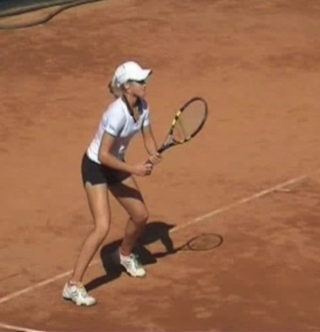

- broad internal
- broad external
- narrow internal
- narrow external

- The IZOF:
- is a model used to understand the influence of emotions on performance
- proposes that individual athletes react differently to the same level of experienced emotion
- is where the ‘OF’ represents the words ‘optimal functioning’
- all of the above

- Which of the following terms complete the statement below correctly?
To accomplish a forward kicking action of the foot, the knee joint ___________ and the hamstring muscles act as the ___________ and the quadriceps act as the ______________

- extends, antagonist, agonist
- flexes, antagonist, agonist
- extends, agonist, antagonist
- flexes, agonist, antagonist

- When an athlete is over-aroused for a specific situation, such as deciding to pass the ball or shoot for goal, they:
- should use progressive relaxation to reduce the cognitive symptoms of anxiety
- will likely increase the field of information that is attended to and see all of the options
- will likely narrow the field of information that is attended to and not see all of the options
- will be in the IZOF

- The skill classification system of ‘discrete-serial-continuous’ is best represented by the following examples in the correct order?
- a gymnastics routine, surfing, pistol shooting
- serving in tennis, a spike in volleyball, a free throw in basketball
- hitting a golf drive, a dance routine, walking
- swimming, a dance routine, pitching a softball
- Using the Information Processing model to your advantage, you would attempt to:
- add additional stimuli for your opponent to process
- hit the ball to the same place on the court
- give your opponent only one stimuli to process
- delay your opponents’ intrinsic feedback

- An adaptation of long term aerobic training is improved utilisation of which of the following sources of energy during submaximal exercise?
- fat
- carbohydrate
- protein
- water

- In rehabilitation, a resistance training machine that maintains constant velocity throughout the entire exercise is used to test, diagnose and train individuals recovering from injury. This machine is using which resistance training type?
- isometric
- isotonic
- isokinetic
- isospecific

- A diver coming off a platform is affected by gravity and falls at an increasing velocity when measured every second. What does this mean for the diver’s acceleration?
- it is decreasing
- it is constant
- it is increasing
- it cannot be determined

- “The direction and intensity of one’s efforts, relating to the initiation, continuation and intensity of behaviour’ is best described as a definition of;
- stress management
- concentration
- arousal
- motivation

END OF SECTION ONE

SECTION TWO – SHORT ANSWER (60 MARKS)

This section has twelve (12) questions. Answer all questions. Write your answers in the spaces provided in this Question/Answer Booklet. Wherever possible, confine your answers to the line spaces provided. Use a blue or black pen (not pencil) for this section.

Spare pages are included at the end of this booklet. They can be used for planning your responses and/or as additional space if required to continue an answer.
- Planning: If you use the spare pages for planning, indicate this clearly at the top of the page.
- Continuing an answer: if you need to use the space to continue an answer, indicate in the original answer space where the answer is continued, i.e. give the page number. Fill in the number of the question(s) that you are continuing to answer at the top of the page.

Suggested working time: 75 minutes.

Question 21 (3 marks)

The graphs below represent the impulse for two different catching performances. They represent catching a cricket ball with bare hands. Identify which graph represents the catch that is likely to hurt least and explain the technique that may have been used to achieve a less painful outcome.

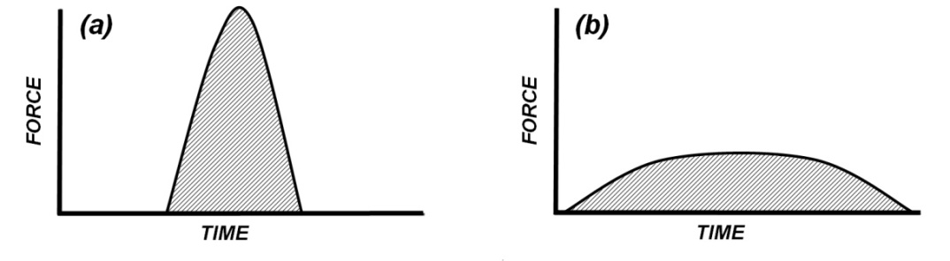
___________________________________________________________________________________
___________________________________________________________________________________

Question 22 (3 marks)

Explain how the body manipulates air pressure in order to perform inspiration (breathe in)
___________________________________________________________________________________
___________________________________________________________________________________
___________________________________________________________________________________
___________________________________________________________________________________
___________________________________________________________________________________
___________________________________________________________________________________
___________________________________________________________________________________
___________________________________________________________________________________
___________________________________________________________________________________
___________________________________________________________________________________
Question 23 (2 marks)

State 2 ways by which an athlete could decrease their base of support if this was their starting position

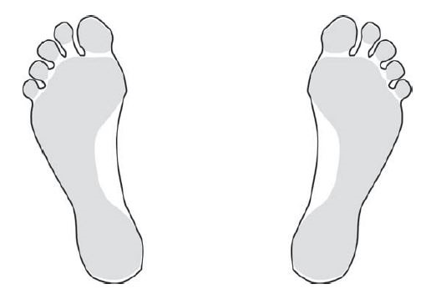

- _____________________________________________________________________________
____________________________________________________________________________

- _____________________________________________________________________________
____________________________________________________________________________

Question 24 (6 marks)

Using the diagram below, identify the anatomical structures as indicated

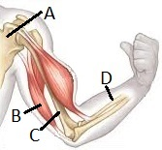

- Name of bone (A) ______________________________________________________________

- Name of muscle (B) _____________________________________________________________

- Action of muscle (B) ____________________________________________________________

- Name of bone (C) ______________________________________________________________

- Name of bone (D) ______________________________________________________________

- Name of structure that connects muscle to bone ______________________________________
Question 25 (4 marks)

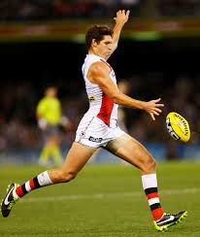

Name the type of balance involved in the above situation and describe three ways the athlete could improve his stability

- Type of stability ________________________________________________________________

- How can stability be improved? ____________________________________________________
___________________________________________________________________________________
___________________________________________________________________________________
___________________________________________________________________________________
___________________________________________________________________________________
___________________________________________________________________________________
___________________________________________________________________________________
___________________________________________________________________________________
___________________________________________________________________________________

Question 26. (4 marks)

Muscular endurance and muscular power are critical fitness components for a kayak paddler. Define these components and name a type of training that would improve each component

- Muscular endurance ____________________________________________________________
- Type of training ________________________________________________________________
- Muscular power ________________________________________________________________
- Type of training ________________________________________________________________
Question 27 (7 marks)

When individuals are learning a new skill, a range of guidance techniques can be used to inform the learner of the key components of performance. These are known as cues to improve performance and include visual, verbal and proprioceptive.
- Describe in detail, with the use of examples, two visual cues to improve performance. (4 marks)
___________________________________________________________________________________
___________________________________________________________________________________
___________________________________________________________________________________
___________________________________________________________________________________
___________________________________________________________________________________
___________________________________________________________________________________
___________________________________________________________________________________

- Define and provide a sporting example of where a coach can assist a learner using a proprioceptive cue. (3 marks)
___________________________________________________________________________________
___________________________________________________________________________________
___________________________________________________________________________________
___________________________________________________________________________________
___________________________________________________________________________________

Question 28. (4 marks)

A high jumper is not pleased with his ‘run up and take-off’ (Figure 10). He tells his coach that his run-up is not right; “I had to stretch the last stride to attain the desired take-off spot”. His coach tells him, “you cleared the bar by 10cm”.

- Define the specific type of feedback the high-jumper is describing to his coach. (1 mark)
___________________________________________________________________________________

- Define the specific type of feedback the coach is providing. (1 mark)
___________________________________________________________________________________

- Justify the use of either terminal or concurrent feedback when the coach is giving the high-jump athlete information about the required execution of the next jump. (2 marks)
___________________________________________________________________________________
___________________________________________________________________________________
___________________________________________________________________________________
___________________________________________________________________________________
Question 29. (8 marks)

- Explain, with the use of a labelled graph, the inverted-U hypothesis. (5 marks)

___________________________________________________________________________________
___________________________________________________________________________________
___________________________________________________________________________________
___________________________________________________________________________________
___________________________________________________________________________________
___________________________________________________________________________________
___________________________________________________________________________________

- Individual differences can cause a change or shift in the inverted-U. Draw another separate, labelled graph of one other factor that can cause a change or shift in the inverted-U and briefly explain. (3 marks)

___________________________________________________________________________________
___________________________________________________________________________________
___________________________________________________________________________________
___________________________________________________________________________________
___________________________________________________________________________________
___________________________________________________________________________________
Question 30 (9 marks)

The graph below shows the sequence of energy source activation within an active muscle.
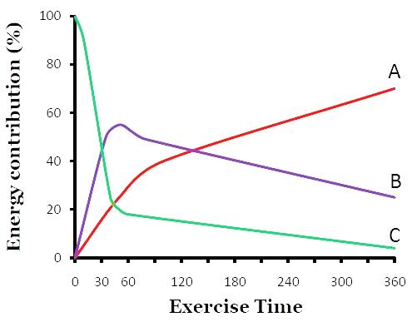

- What chemical compound is used to produce energy? __________________________________
_____________________________________________________________________________

- Which energy system is represented by line B? _______________________________________

- What causes the decline of line C? _________________________________________________

- What is the predominant energy system after 4 minutes? _______________________________

- What is the preferred fuel source for high intensity exercise? _____________________________

- Explain the interplay of energy systems that would occur whilst playing a game of soccer
___________________________________________________________________________________
___________________________________________________________________________________
___________________________________________________________________________________
___________________________________________________________________________________
___________________________________________________________________________________
___________________________________________________________________________________
___________________________________________________________________________________
___________________________________________________________________________________
___________________________________________________________________________________
___________________________________________________________________________________
___________________________________________________________________________________
___________________________________________________________________________________

Question 31 (7 marks)

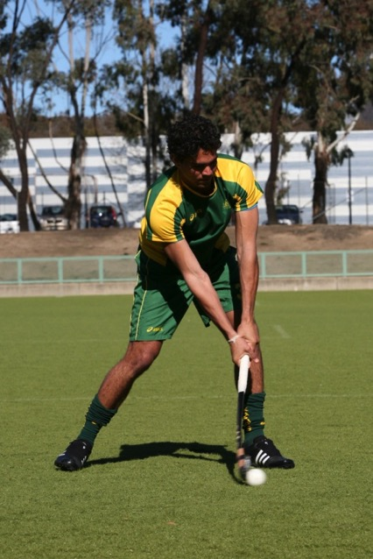
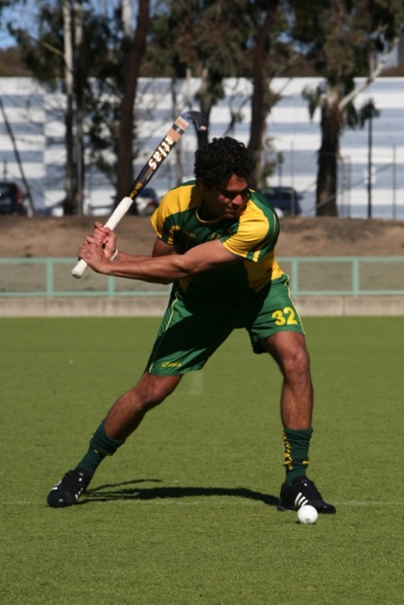

- Identify the type of force summation represented by the hockey hit (1 mark)
___________________________________________________________________________________

- Discuss, from a biomechanical perspective, how the athlete maximises the velocity of the hockey ball when hit. (6 marks)
___________________________________________________________________________________
___________________________________________________________________________________
___________________________________________________________________________________
___________________________________________________________________________________
___________________________________________________________________________________
___________________________________________________________________________________
___________________________________________________________________________________
___________________________________________________________________________________
___________________________________________________________________________________

Question 32 (3 marks)

One of the SMARTS/SMARTER principles is ‘Realistic’. Outline what is represented by the first ‘S’, the ‘A’ and the ‘T’ of SMARTS/SMARTER principles of effective goal setting.
___________________________________________________________________________________
___________________________________________________________________________________
___________________________________________________________________________________
___________________________________________________________________________________
___________________________________________________________________________________

END OF SECTION TWO
SECTION THREE – EXTENDED ANSWER (30 MARKS)

This section contains four (4) questions. You must answer two (2) questions. Write your answers in the space provided.

Spare pages are included at the end of this booklet. They can be used for planning your responses and/or as additional space if required to continue an answer.
- Planning: If you use the spare pages for planning, indicate this clearly at the top of the page.
- Continuing an answer: if you need to use the space to continue an answer, indicate in the original answer space where the answer is continued, i.e. give the page number. Fill in the number of the question(s) that you are continuing to answer at the top of the page.

Suggested working time: 45 minutes.

Question 33. (15 marks)

Golf is consistently ranked as one of Australia’s most of popular sports based on participation.

A golf shot (Iron)
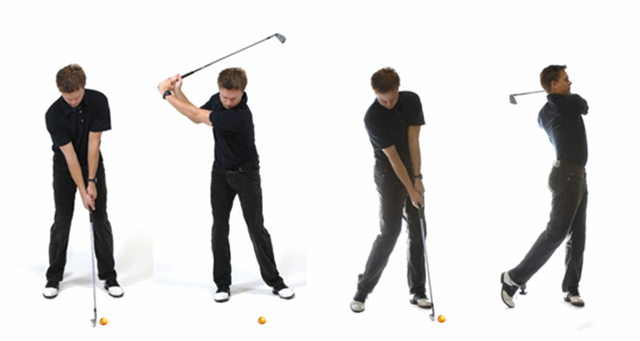

- Define and explain Newton’s First Law of Motion in relation to the golf shot. (3 marks)
___________________________________________________________________________________
___________________________________________________________________________________
___________________________________________________________________________________
___________________________________________________________________________________
___________________________________________________________________________________
___________________________________________________________________________________
___________________________________________________________________________________
___________________________________________________________________________________
___________________________________________________________________________________
___________________________________________________________________________________
___________________________________________________________________________________

- Define and explain Newton’s Second Law of Motion in relation to the golf shot. (3 marks)
___________________________________________________________________________________
___________________________________________________________________________________
___________________________________________________________________________________
___________________________________________________________________________________
___________________________________________________________________________________
___________________________________________________________________________________
___________________________________________________________________________________

- Define and explain Newton’s Third Law of Motion in relation to the golf shot. (3 marks)
___________________________________________________________________________________
___________________________________________________________________________________
___________________________________________________________________________________
___________________________________________________________________________________
___________________________________________________________________________________
___________________________________________________________________________________

- Golf requires a high level of concentration. Explain Nideffer’s Model of attention and describe which attentional style would be most applicable to golf. (6 marks)

___________________________________________________________________________________
___________________________________________________________________________________
___________________________________________________________________________________
___________________________________________________________________________________
___________________________________________________________________________________
___________________________________________________________________________________
___________________________________________________________________________________
___________________________________________________________________________________
___________________________________________________________________________________
Question 34. (15 marks)

An elite triathlete.

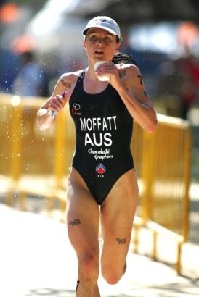

Elite triathletes can complete the Olympic Triathlon distance (swim=1.5km; ride=40km; run=10km) in less than 2 hours. However, adaptations to training are not permanent and can be lost with detraining. This is the principle of reversibility of training.
- Outline the two other main, relevant principles of training and explain how an elite triathlete could apply them to training. (4 marks)
___________________________________________________________________________________
___________________________________________________________________________________
___________________________________________________________________________________
___________________________________________________________________________________
___________________________________________________________________________________
___________________________________________________________________________________
___________________________________________________________________________________
___________________________________________________________________________________
___________________________________________________________________________________
___________________________________________________________________________________
___________________________________________________________________________________

- Training for three different disciplines requires variability in the training schedule. What are the three most important types of training and how could they be applied? (6 marks)
___________________________________________________________________________________
___________________________________________________________________________________
___________________________________________________________________________________
___________________________________________________________________________________
___________________________________________________________________________________
___________________________________________________________________________________
___________________________________________________________________________________
___________________________________________________________________________________
___________________________________________________________________________________
___________________________________________________________________________________
___________________________________________________________________________________
___________________________________________________________________________________
___________________________________________________________________________________
___________________________________________________________________________________
___________________________________________________________________________________
___________________________________________________________________________________
___________________________________________________________________________________

- In an individual sport, mental skills are critical to overall success. Briefly describe five mental skills techniques the athlete may choose to utilise to help them cope with pressure. (5 marks)
___________________________________________________________________________________
___________________________________________________________________________________
___________________________________________________________________________________
___________________________________________________________________________________
___________________________________________________________________________________
___________________________________________________________________________________
___________________________________________________________________________________
___________________________________________________________________________________
___________________________________________________________________________________
___________________________________________________________________________________
___________________________________________________________________________________
___________________________________________________________________________________
___________________________________________________________________________________

Question 35 (15 marks)

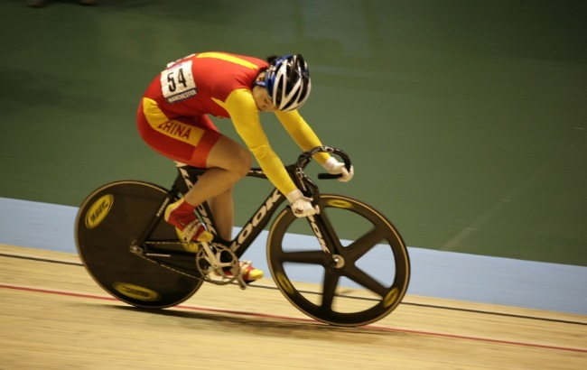

Many sports utilise different types of motion.
- Consider an athlete in motion during a cycling event (pictured above). Identify and briefly explain the application of each type of motion in this activity. (5 marks)
___________________________________________________________________________________
___________________________________________________________________________________
___________________________________________________________________________________
___________________________________________________________________________________
___________________________________________________________________________________
___________________________________________________________________________________
___________________________________________________________________________________
___________________________________________________________________________________
___________________________________________________________________________________
___________________________________________________________________________________

- Ball sports involve the manipulation of a projectile. Outline the three critical factors that govern the behaviour of a projectile. (6 marks)
___________________________________________________________________________________
___________________________________________________________________________________
___________________________________________________________________________________
___________________________________________________________________________________
___________________________________________________________________________________
___________________________________________________________________________________
___________________________________________________________________________________
___________________________________________________________________________________
___________________________________________________________________________________
___________________________________________________________________________________
___________________________________________________________________________________
___________________________________________________________________________________
___________________________________________________________________________________
___________________________________________________________________________________
___________________________________________________________________________________

- Explain the two different sources of motivation and how increasing skill level of the athlete may cause the source of motivation to change over time. (4 marks)
___________________________________________________________________________________
___________________________________________________________________________________
___________________________________________________________________________________
___________________________________________________________________________________
___________________________________________________________________________________
___________________________________________________________________________________
___________________________________________________________________________________
___________________________________________________________________________________
___________________________________________________________________________________
___________________________________________________________________________________
___________________________________________________________________________________

Question 36 (15 marks)

Raphael Nadal is in the third phase of learning according to the Fitts and Posner model.
- What is this third phase of learning called and what are six important characteristics of an elite athlete in this stage? (7 marks)
___________________________________________________________________________________
___________________________________________________________________________________
___________________________________________________________________________________
___________________________________________________________________________________
___________________________________________________________________________________
___________________________________________________________________________________
___________________________________________________________________________________
___________________________________________________________________________________
___________________________________________________________________________________
___________________________________________________________________________________
___________________________________________________________________________________
___________________________________________________________________________________
___________________________________________________________________________________
___________________________________________________________________________________
___________________________________________________________________________________
___________________________________________________________________________________
___________________________________________________________________________________
___________________________________________________________________________________
___________________________________________________________________________________

- Any player facing Nadal in a match would potentially experience stress. Identify and describe the four stages of the stress process. (8 marks)
___________________________________________________________________________________
___________________________________________________________________________________
___________________________________________________________________________________
___________________________________________________________________________________
___________________________________________________________________________________
___________________________________________________________________________________
___________________________________________________________________________________
___________________________________________________________________________________
___________________________________________________________________________________
___________________________________________________________________________________
___________________________________________________________________________________
___________________________________________________________________________________
___________________________________________________________________________________
___________________________________________________________________________________
___________________________________________________________________________________
___________________________________________________________________________________
___________________________________________________________________________________
___________________________________________________________________________________
___________________________________________________________________________________
___________________________________________________________________________________
___________________________________________________________________________________
___________________________________________________________________________________
___________________________________________________________________________________
___________________________________________________________________________________
___________________________________________________________________________________
___________________________________________________________________________________
___________________________________________________________________________________
___________________________________________________________________________________
___________________________________________________________________________________
END OF EXAM
___________________________________________________________________________________
___________________________________________________________________________________
___________________________________________________________________________________
___________________________________________________________________________________
___________________________________________________________________________________
___________________________________________________________________________________
___________________________________________________________________________________
___________________________________________________________________________________
___________________________________________________________________________________
___________________________________________________________________________________
___________________________________________________________________________________
___________________________________________________________________________________
___________________________________________________________________________________
___________________________________________________________________________________
___________________________________________________________________________________
___________________________________________________________________________________
___________________________________________________________________________________
___________________________________________________________________________________
___________________________________________________________________________________
___________________________________________________________________________________
___________________________________________________________________________________
___________________________________________________________________________________
___________________________________________________________________________________
___________________________________________________________________________________
___________________________________________________________________________________
___________________________________________________________________________________
___________________________________________________________________________________
___________________________________________________________________________________
___________________________________________________________________________________
___________________________________________________________________________________
___________________________________________________________________________________

___________________________________________________________________________________
___________________________________________________________________________________
___________________________________________________________________________________
___________________________________________________________________________________
___________________________________________________________________________________
___________________________________________________________________________________
___________________________________________________________________________________
___________________________________________________________________________________
___________________________________________________________________________________
___________________________________________________________________________________
___________________________________________________________________________________
___________________________________________________________________________________
___________________________________________________________________________________
___________________________________________________________________________________
___________________________________________________________________________________
___________________________________________________________________________________
___________________________________________________________________________________
___________________________________________________________________________________
___________________________________________________________________________________
___________________________________________________________________________________
___________________________________________________________________________________
___________________________________________________________________________________
___________________________________________________________________________________
___________________________________________________________________________________
___________________________________________________________________________________
___________________________________________________________________________________
___________________________________________________________________________________
___________________________________________________________________________________
___________________________________________________________________________________
___________________________________________________________________________________
___________________________________________________________________________________

___________________________________________________________________________________
___________________________________________________________________________________
___________________________________________________________________________________
___________________________________________________________________________________
___________________________________________________________________________________
___________________________________________________________________________________
___________________________________________________________________________________
___________________________________________________________________________________
___________________________________________________________________________________
___________________________________________________________________________________
___________________________________________________________________________________
___________________________________________________________________________________
___________________________________________________________________________________
___________________________________________________________________________________
___________________________________________________________________________________
___________________________________________________________________________________
___________________________________________________________________________________
___________________________________________________________________________________
___________________________________________________________________________________
___________________________________________________________________________________
___________________________________________________________________________________
___________________________________________________________________________________
___________________________________________________________________________________
___________________________________________________________________________________
___________________________________________________________________________________
___________________________________________________________________________________
___________________________________________________________________________________
___________________________________________________________________________________
___________________________________________________________________________________
___________________________________________________________________________________
___________________________________________________________________________________

